

# VISVESVARAYA TECHNOLOGICAL UNIVERSITY

**Belagavi-590018, Karnataka**

**A Project Report on**

**“STORE MANAGEMENT SYSTEM”**

*Submitted in partial fulfillment for the award of the degree in*

# Bachelor of Engineering in Computer Science & Engineering

Submitted by

## AMRIT TULSYAN USN: 1BH20CS004

**CHANDAN GOWDA USN: 1BH20CS012**

Under the guidance of

# Mrs. SARANYA S.

Assistant Professor

Dept. of Computer Science & Engineering

BANGALORE TECHNOLOGICAL INSTITUTE

(ISO 9001:2015 Certified Institute) Sarjapura Road, Kodathi, **Bangalore-560035**

**Department of Computer Science & Engineering**

|  |  |  |
| --- | --- | --- |
|  | **BANGALORE TECHNOLOGICAL INSTITUTE**  **(An ISO 9001:2015 Certified Institute)**  **Department of Computer Science and Engineering** |  |

**CERTIFICATE**

This is to certify that the mini-project work entitled "**STORE MANAGEMENT SYSTEM"** carried out by **AMRIT TULSYAN [1BH20CS004]** and **CHANDAN GOWDA [1BH20CS012]** are the bonafide students of **Bangalore Technological Institute**, **Bangalore** in partial fulfillment for the award of **Bachelor of Engineering in Computer Science and Engineering** of **Visvesvaraya Technological University, Belgavi** during the year **2022-23**. The mini-project report has been approved, as it satisfies the academic requirement in the respect of the project report prescribed for the said degree.

…………………………… ………………………………. ……………………

# Mrs. Saranya S Dr. Sohan Kumar Gupta Dr. H S Nanda

Guide, Department of CSE H.O.D, Department of CSE Principal

# External Viva

## Name of the Examiners Signature with date

**1**………………………. ………………………

**2**………………………. ………………………

|  |  |  |
| --- | --- | --- |
|  | **BANGALORE TECHNOLOGICAL INSTITUTE**  **(An ISO 9001:2015 Certified Institute)**  **Department of Computer Science and Engineering** |  |

**DECLARATION**

We are students of fifth semester **BE COMPUTER SCIENCE AND ENGINEERING, BANGALORE TECHNOLOGICAL INSTITUTE,**

**BANGALORE,** hereby declare that the project work entitled “**STORE MANAGEMENT SYSTEM**” has been independently carried out by us at **Bangalore Technological Institute, Bengaluru** and submitted in partial fulfillment of the requirements for the award of the degree in **Bachelor of Engineering in Computer Science & Engineering** of the **Visvesvaraya Technological University, Belagavi** during the academic year **2022-23**.

We also declare that, to the best of our knowledge and believe the work reported here does not form or part of any other dissertation on the basis of which a degree or award was conferred on an early occasion of this by any other students.

PALCE: BENGALURU DATE:

|  |  |  |
| --- | --- | --- |
| **AMRIT TULSYAN**  **CHANDAN GOWDA** | **1BH20CS004**  **1BH19CS012** | **………………………….**  **………………………….** |

# ACKNOWLEDGEMENT

Any achievement, be it scholastic or otherwise does not depend solely on the individual efforts but on the guidance, encouragement and cooperation of intellectuals and elders. We wouldlike to take this opportunity to thank them all.

We heartily extend our words of gratitude to our guide, **Asst Prof. Saranya S**, for her valuable advice, encouragement and suggestion given to us in the course of our mini-project work.We convey our gratitude to her for having constantly monitored the development of the mini- project and setting up precise deadlines.

We would like to express our immense gratitude to Head of Department **Dr. Sohan Kumar Gupta**, for his unfailing encouragement and suggestion given to us in courseof our work.

We would like to take this opportunity to express our gratitude to the Principal, **Dr. H S Nanda**, for giving us this opportunity to enrich our knowledge.

We are grateful to the President **Dr. A Prabhakara Reddy** and Secretary, **Sri. C LGowda** for having provided us with a great infrastructure and well-furnished labs.

Finally, a note of thanks to the Department of Computer Science and Engineering, bothteaching and non-teaching staff for their co-operation extended to us.

Last but not the least, we acknowledge the support and feedback of our parents, guardiansand friends, for their indispensable help always

**AMRIT TULSYAN**

**[1BH20C004]**

**CHANDAN GOWDA**

**[1BH20CS012]**

# ABSTRACT

The "Store Management System" is a mini database management system (DBMS) project that aims to automate and streamline the operations of a retail store. The system is designed to help store managers efficiently manage inventory, track sales, and generate reports. The project will allow store managers to easily access and update inventory information, monitor sales trends, and make data-driven decisions to improve the overall performance of their store. This system is designed to be user-friendly and intuitive, making it easy for managers to navigate and utilize the various features. The system is built using a relational database management system (RDBMS) to store and organize data, and it utilizes a graphical user interface (GUI) to allow for easy data entry and retrieval. The goal of this project is to create a powerful and flexible tool that can help store managers optimize their operations and improve the bottom line.

# TABLE OF CONTENTS

**CHAPTER PAGE No.**

1. INTRODUCTION 1-4

1.1 Database.................................................................................................................

1.2 Database Management System..............................................................................

1.3 Application..............................................................................................................

1.4 Introduction To MySQL............................................................................................

1.5 Oracle.......................................................................................................................

1.6 Introduction To Project……………………………………………………………………

1. LITERATURE SURVEY 5-6

2.1 Related Work..........................................................................................................

2.2 Program Design......................................................................................................

2.3 Data Design..............................................................................................................

1. PROBLEM STATEMENT 7

3.1 Existing System.......................................................................................................

3.2 Proposed System....................................................................................................

1. REQUIREMENT & SPECIFICATION 8

4.1 Hardware Requirement.....................................................................................

4.2 Software Requirement......................................................................................

## SYSTEM DESIGN 9-13

5.1 Data Flow Diagram…………………………………………………………….

5.1.1 Level 0 DFD…………………………………………………………..

5.1.2 Level 1 DFD…………………………………………………………..

5.1.3 Level 2 DFD…………………………………………………………..

5.2 ER Diagram……………………………………………………………………..

5.2 Class Diagram………………………………………………………………….

## IMPLEMENTATION 14

# 7.CONCLUSION 15

**REFERENCES**

**APPENDIX**......................................................................................................................

Home/Sign In Page…………………………………………………………………………………………….…….

Bus Time Table……………………………………………………………………………………………………..……

User Finding Schedule………………..……….……………………………………………………………………

Showing Available Buses………………………………..……...…...................................................

User Personal Details ……………………………………………………………………………………………...

User Reference Number…………………………………………………………………............................

Admin Login Session…………………………………………………..................................................

Admin Home Page……….…………………………………………………………………………………………..

Client Reservation List……………………………………………………………………………………………..

Bus List………………………………………………………………………………………..……………..………….

Bus Location……………….………………………………………………………………………………………….

Bus Schedule List…………………………………………………………………………………………………….

Administrator………………………………………………………………………..………………………………

|  |  |  |
| --- | --- | --- |
|  | **LIST OF FIGURES** |  |
| **S.No** | **Title** | **Page No.** |
| 1 | Components of DBMS | 2 |
| 2 | Level 0 DFD Diagram | 9 |
| 3 | Level 1 DFD Diagram | 10 |
| 4 | Level 2 DFD Diagram | 11 |
| 5 | ER Diagram | 12 |
| 6 | Class Diagram | 13 |

## Chapter 1

## Database

# INTRODUCTION

A database is an organized collection of data. A relational

database, more restrictively, is a collection of schemas, tables, queries, reports, views, and other elements. Database designers typically organize the data to model aspects of reality in a way that supports processes requiringinformation, such as (for example) modelling the availability of rooms in hotels in a way that supports finding a hotel with vacancies. A database is not generally portable across different DBMSs, but different DBMSs can interoperate by using standards such as SQL and ODBC or JDBC to allow a single application to work with more than one DBMS. Computer scientists may classify database-management systems according to the database models that they support; the most popular database systems since the 1980s have all supported the relational model - generally associated with the SQL language. HB Sometimes a DBMS is loosely referred to as a "database".

## Database Management System

A database-management system (DBMS) is a collection of interrelated data and a set of programs to access those data. This is a collection of related data with an implicit meaning and hence is a database. The collection of data, usually referred to as the database, contains information relevant to an enterprise. The primary goal of a DBMS is to provide a way to store and retrieve database information that is both convenient and efficient. By data, we mean known facts that can be recorded and that have implicit meaning. For example, consider the names, telephone numbers, and addresses of the people you know. You may have recorded this data in an indexed address book, or you may have stored it on a diskette, using a personal computer and software such as DBASE IV or V, Microsoft ACCESS, or EXCEL. While information can be transported, stored or shared without many difficulties the same cannot be said about knowledge. Database systems are designed to manage large bodies of information. Management of data involves both defining structures for storage of information and providing mechanisms for Store Management System the manipulation of information. In addition, the database system must ensure the safety of the information stored,

despite system crashes or attempts at unauthorized access. If data are to be shared among several users, the system must avoid possible anomalous results. Because information is so important in most organizations, computer scientists have developed a large body of concepts and techniques for managing data.

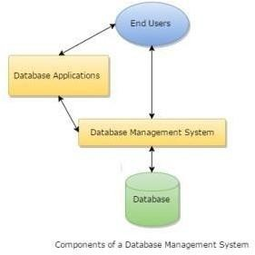

**Fig 1.1: Components of a database management system**

## Application

Database are widely used. The some of the representative applications are:

* + 1. Banking: For customer information, accounts and loans and banking transactions.
    2. Universities: For student registrations and grades.
    3. Online Shopping: Everyone wants to shop from home. Everyone new products are added and sold only with the help of DBMS. Purchase information, invoice bills and payment, all of these are done with the help of DBMS.
    4. Airlines: For reservations and schedule information.
    5. Credit card transactions: For purchases on credit cards and generation of

monthly statements.

* + 1. Library Management System: Maintain all the information related to book issue dates, name of the book, author and availability of the book.
    2. Telecommunications: For keeping records of call made, generating monthly bills, maintaining balances on prepaid calling cards.
    3. Sales: For customer, product and purchase information.
    4. Finance: For storing information about holdings, sales, and purchases of financial instruments such as stocks and bonds.
    5. Human resource: For information about employees, salaries, payroll taxes and benefits.

## Introduction To MySQL

MYSQL is a relational database management system (RDBMS) that runs as a server providing multi-user access to a number of databases. MYSQL is a popular choice of database for use in web applications and is an open-source product. The process of setting up a MYSQL database varies from host to host, however we will end up with a database name, a user name and a password. Before using our database, we must create a table. A table is a section of the database for storing related information. In a table, we will set up the different fields which will be used in that table. Creating a table in phpMyAdmin is simple, we just type the name, select the number of fields and click the ‘go’ button. We will then be taken to a setup screen where you must create the fields for the database. Another way of creating databases and tables in phpMyAdmin is by executing simple SQL statements. We have used this method in order to create our database and tables.

## Oracle

The current version of oracle database is the result of 30 years of

innovative development. Highlights in the evolution of oracle database include the following:

* Founding of oracle in 1997, Larry Ellison, bob miner, and Ed Oates started the consultancy software development laboratories, which became relational software, Inc. (RSI). In 1983, RSI became Oracle systems Corporation and then later Oracle corporation.
* First commercially available RMSDB In 1979, RSI introduced Oracle V2 (version 2) as the first commercially available SQL-based RDBMS, a landmark event in the history of relational databases.
* Portable version of Oracle Databases Oracle version 3, released in 1983, was the first relational databases to run on mainframes, minicomputers and PCs. The database was written in C, enabling the database to be ported to multiple platforms.
* Enhancements to concurrency control, data distribution, and scalability Version 4 introduced multi version read consistency version 5, released in 1985, supported client/server computing and distributed database systems version 6 brought enhancements to disk I/O, row locking, scalability and backup and recovery. Also, version 6 introduced the first version of thePL/SQL language, a proprietary procedural extension to SQL.

## Introduction To Project

Store Management System (SMS) is Web based application that works within centralized network. The software program “Store Management System” focus on managing and automating the databases of a retail store. The SMS would likely allow store employees to manage inventory and track sales. It would also likely maintain data on products, employees, and customers

## Chapter 2

## Related Work

# LITERATURE SURVEY

It is a challenging task to obtain realistic input values for the mathematical inventory model parameters. The decision-making person performing this task is often operating in an environment, with unknown parameters. In inventory control, it is associated with the uncertainty of customer demand rates, manufacturing and delivery lead times. The models and methods of decision-making in existing theory of inventory management are usually focused on deterministic parameters and modules do not meet the full requirements of the real environment. In such cases, fuzzy models of inventory management take an important place. Fuzzy set theory suggests methods of dealing with imprecision and uncertainty in a quantitate way. Fuzzy logic is widely used in solving problems of riskology, problems of artificial intelligence as in building expert systems, and in combination with artificial neural networks. The theoretical basis of fuzzy logic constitutes the fuzzy sets, proposed by Zadeh (1965). It has gained widespread prominence as a means to model vague data in production management applications. Galbraith (1973) defines uncertainty as the difference between the amount of information required to perform a task and the amount of information already possessed. In the real world, many forms of uncertainty affect production processes. Ho (1989) categorizes them into two groups: environmental uncertainty and system uncertainty. Environmental uncertainty includes uncertainties beyond the production process, such as demand uncertainty and supply uncertainty. System uncertainty is related to uncertainties in the production process, such as operation yield uncertainty, production leadtime uncertainty, and quality uncertainty, failure of the production system and changes to product structure, to mention some. A new stage in the theory of inventory management is the emergence of models taking into account uncertainty.

**WHO WILL BENEFIT FROM THIS SERVICE?**

The business idea proposed by this store management system is unique with respect to other store management services policies. The reception of the service by the store managers in huge numbers is still uncertain as the business idea has not been made into function as of now, but the analysis made by the company’s founders show a

massive growth in terms of their response and hence availing this service soon after the application is launched. According to the company representatives when asked about the advantages of such a service, the statement was that, “In today’s fast moving world, people really feel about the importance of time and hence they want no wastage of it. So, everyone is getting drawn towards excellent and professional service that ensures quality and no wastage of unnecessary time. In our opinion, the service provided by us to the people will benefit them largely.

## Program Design

The objective of the SMS is that a user can use the web application from any device and make a successful track of stocks. In order to achieve so, primarily the requirements analysis document has to be studied carefully and thoroughly. To give the idea a reality, a development platform is to be used like development in python or java Script or C++ or java and so on .in this case python has been opted for the development of the SMS. Python supports many packages and modules that ease the functionality to the user. Use of FLASK is advisable. After the application has been developed. a review is to be conducted for ensuring that the implementation of necessary modules is a must. Before releasing it out to the world, a sample must be tried and reviewed by a small group, like stores in the neighborhood and collect those shopkeepers’ s feedback regarding the system. If negative feedbacks or similar statements arrive, then they have to be implemented and rectified in the system and tested again.

## Data Design

The entities participating in the SMS to manage stocks, follow a 1 to Many types of architecture. There is a hierarchy followed by any SMS' data fields. For e.g... Customer details will branch out further as Customer Name, Customer Number and Customer Address and so on. The data stored, will be accessed by Python by establishing a connection with the MySQL database.

## Chapter 3

# PROBLEM STATEMENT

Stocks books are generally maintained as hand written books where their data can be easily destroyed or modified by anyone.

## Existing Scenario

The hand written books in stores maintain the the stock report and details about the customers and the seller. Since the books are hand written sometimes it may get modified by some third person who does not have the permission to do so, which leads to manipulation in data, the books of the store and dealer books does not match and causes problem while tallying it and results in loss of the store.

## Proposed Solution

Maintaining the stock, customer detail and seller detail in this web-based system which can be accessed only by registered user and only the sale bill or purchase bill can be updated so that if there is any data manipulation, we can easily find out the non-matching elements in dealer and store books

**Note: -** To insert the stock data or to fetch the data first they need to Login and only then they will be able to perform such actions.

**Chapter4**

# REQUIREMENT SPECIFICATION

## HARDWARE REQUIREMENTS

The physical components required are:

* Processor - Intel Pentium processor at 500 MHz or faster.
* Memory – 256MB RAM or more.
* Mouse or another pointing device
* Keyboard
* Hard-Disk Drive / Optical Drive

## SOFTWARE REQUIREMENTS

The software being used are:

* Operating system (ex: Windows 10)
* XAMPP
* Visual Studio Code
* Internet browser (ex: Chrome)

**CHAPTER 5**

# SYSTEM DESIGN

## Data Flow Diagram

A data flow diagram (DFD) maps out the flow of information for any process or system. It uses defined symbols like rectangles, circles and arrows, plus short text labels, to show data inputs, outputs, storage points and the routes between each destination. Data flowcharts can range from simple, even hand-drawn process overviews, to in-depth, multi-level DFDs that dig progressively deeper into how the data is handled. We have classified our Data-flow diagram into 3 levels.

* + 1. **Level 0 DFD**

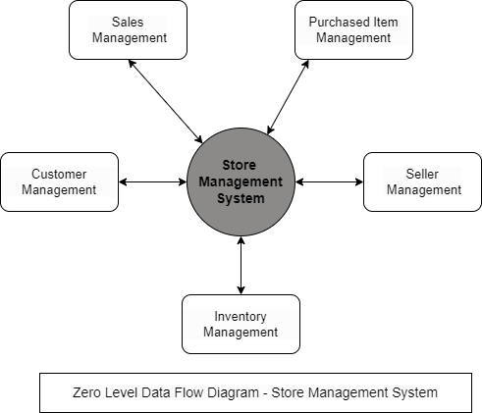

**Fig 5.1: Level Zero DFD**

The figure which is given above represents the level 0 of the dataflow diagram. The Data- flow diagram of level 0 is also called a Context Diagram. It’s a basic

overview of the whole system or process being analyzed or modeled. It’s designed to be an at-a-glance view, showing the system as a single high-level process, with its relationship to external entities. It should be easily understood by a wide audience, including stakeholders, business analysts, data analysts and developers.

* + 1. **Level 1 DFD**

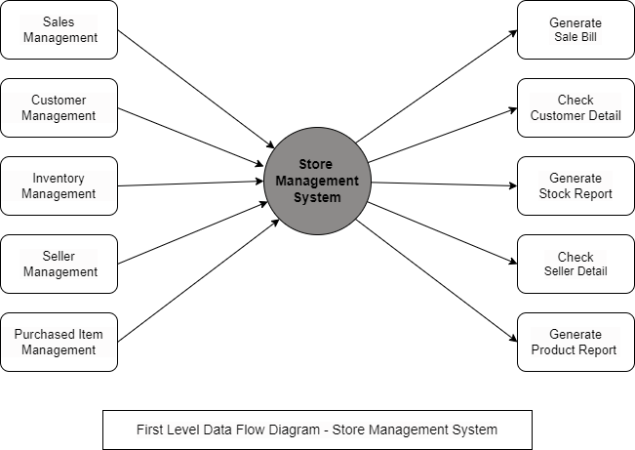

## Fig 5.2: Level One of the DFD

Another level is DFD Level 1 which provides a more detailed breakout of pieces of the Context Level Diagram. You will highlight the main functions carried out by the system, as you break down the high-level process of the Context Diagram into its sub processes.

* + 1. **Level 2 DFD**

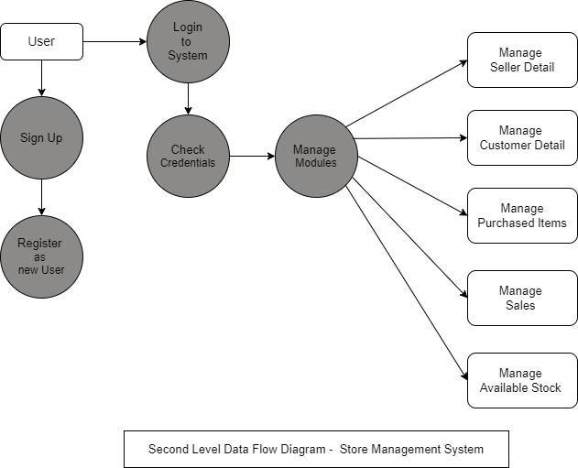

## Fig 5.3: Level 2 of the DFD

Data-flow Diagram Level 2 then goes one step deeper into parts of Level 1. It may require more text to reach the necessary level of detail about the system’s functioning. The level 2the data flow diagram is given above.

## ER Diagram

An entity–relationship model (or ER model) describes

interrelated things of interest in a specific domain of knowledge. A basic ER model is composed of entity types (which classify the things of interest) and specifies relationships that can exist between entities (instances of those entity types). The ER diagram of our project is given below.

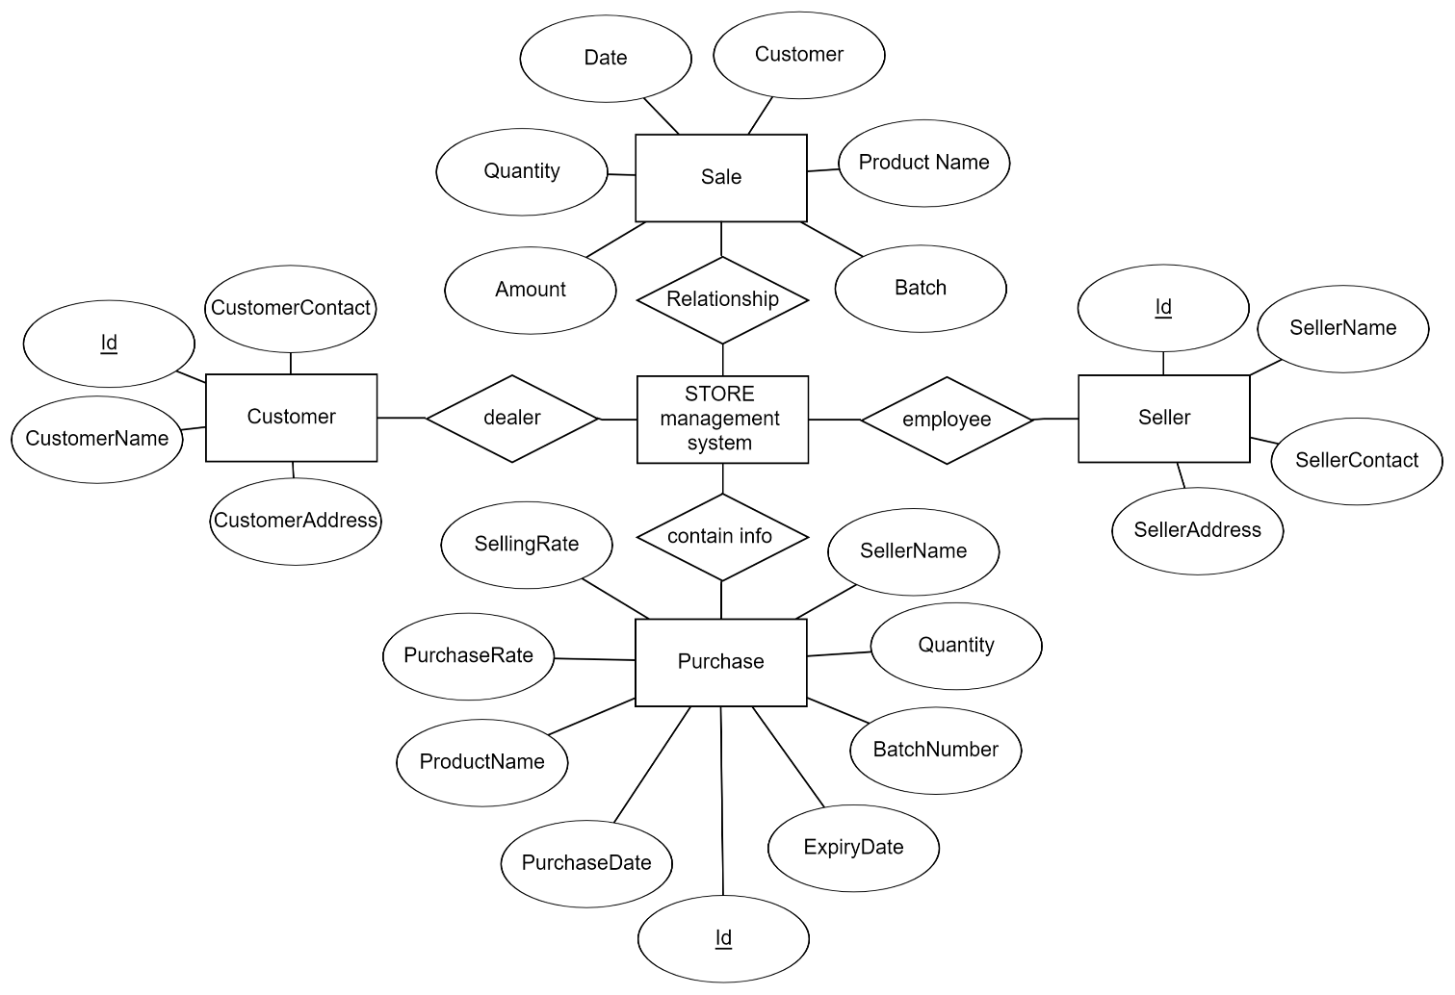

**Fig 5.4: ER Diagram**

# Class Diagram

A class diagram in the Unified Modeling Language (UML) is a type of static structure diagram that describes the structure of a system by showing the system's classes, their attributes, operations (or methods), and the relationships among objects. The class diagram is shown below:

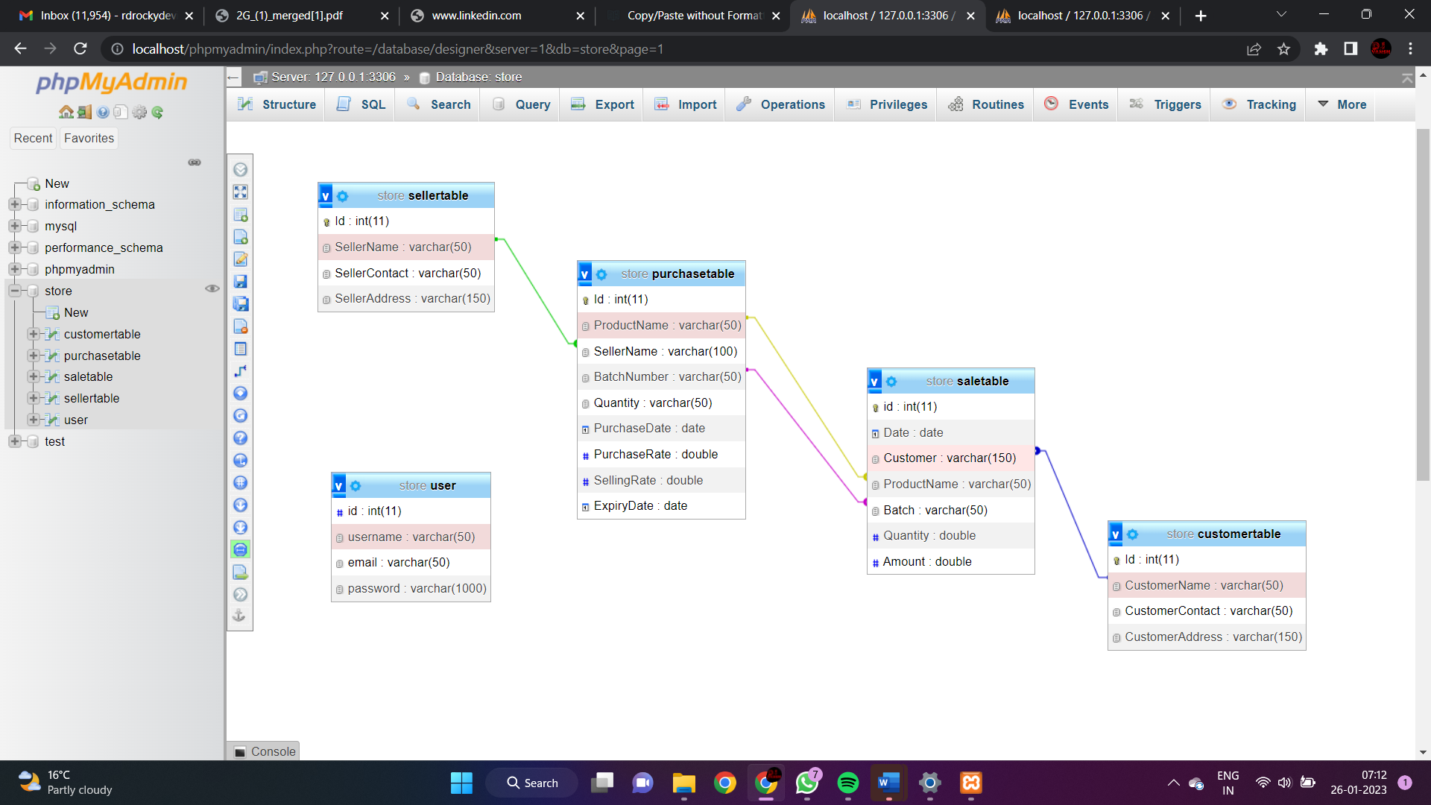

**Fig 5.5 Class Diagram**

**CHAPTER 6**

# IMPLEMENTATION

A store management system is a software application used to manage and automate the operations of a retail store. It typically includes modules for inventory management, point of sale, customer management, and financial reporting. The implementation of a store management system will involve several steps, including:

* Identifying the specific business needs and requirements for the system.
* Researching and selecting a software solution that meets those needs.
* Configuring the system to fit the specific requirements of the store.
* Training employees on how to use the system.
* Testing the system to ensure it is functioning properly.
* Implementing the system in the store.
* Ongoing maintenance and support to ensure the system continues to function properly.

It's important to work with a vendor or developer that has experience in retail store management system implementations to ensure a smooth and successful deployment.

**Chapter 7**

# CONCLUSION

* The purpose of this project is to overcome the written sale books.
* Our Project, "Store Management System" is an idea that will uplift the power concept of inventory management, invoice generation, customer management, and seller management. Our web app can do a lot of benefits to everyone who will use it.
* To conclude that the Store Management System can lead to an error-free, secure, reliable, and fast management system with a user-friendly interface.

# Future Enhancement

* Number of purchase items will be added.
* Number of customers will be added.
* Number of sellers will be added.
* GPS tracking system will be added to each and every car.
* Concept of discount coupon will be added.

# REFERENCES

* https://www.w3schools
* https:/[/www.youtube.com](http://www.youtube.com/)

# APPENDIX: SNAPSHOTS

**SIGN IN PAGE**

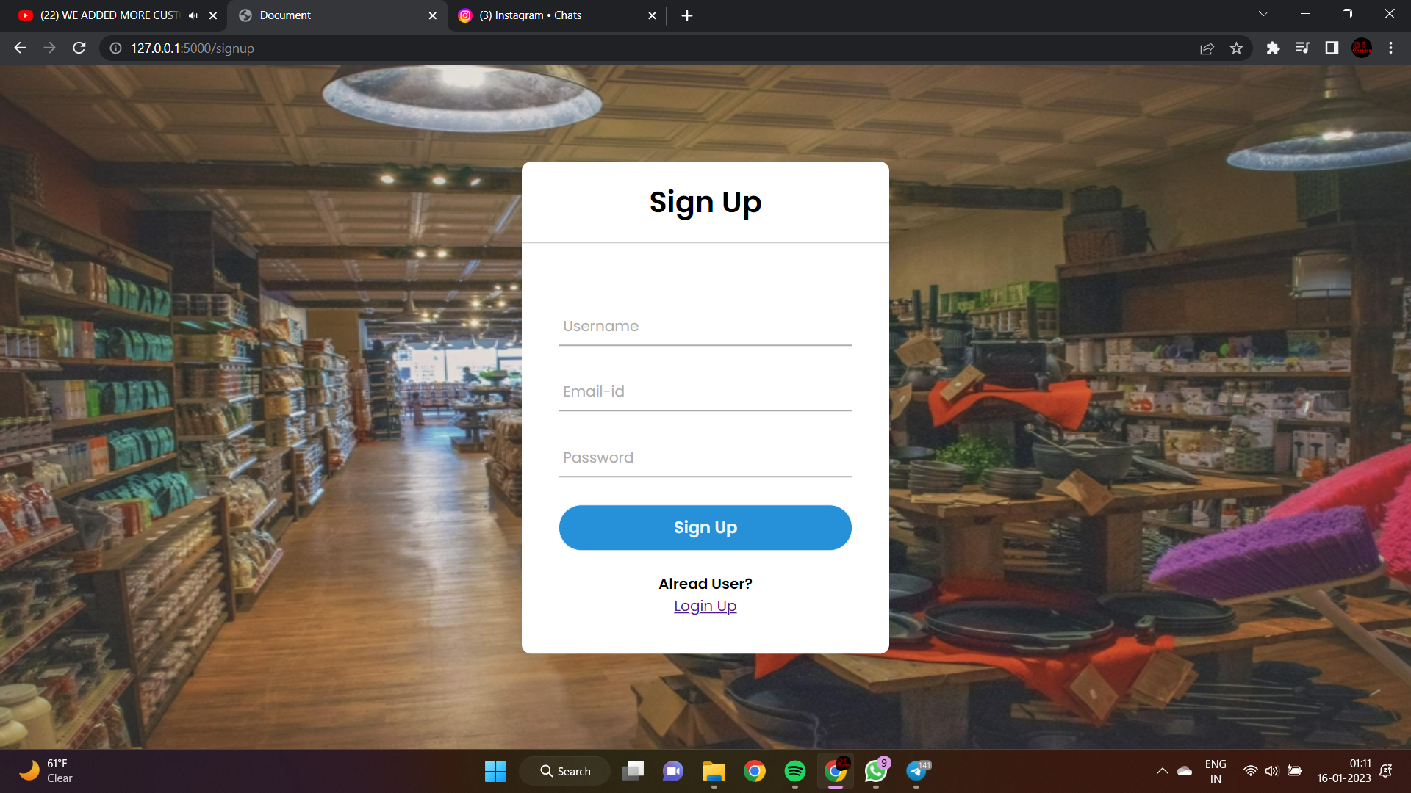

**LOGIN IN PAGE** 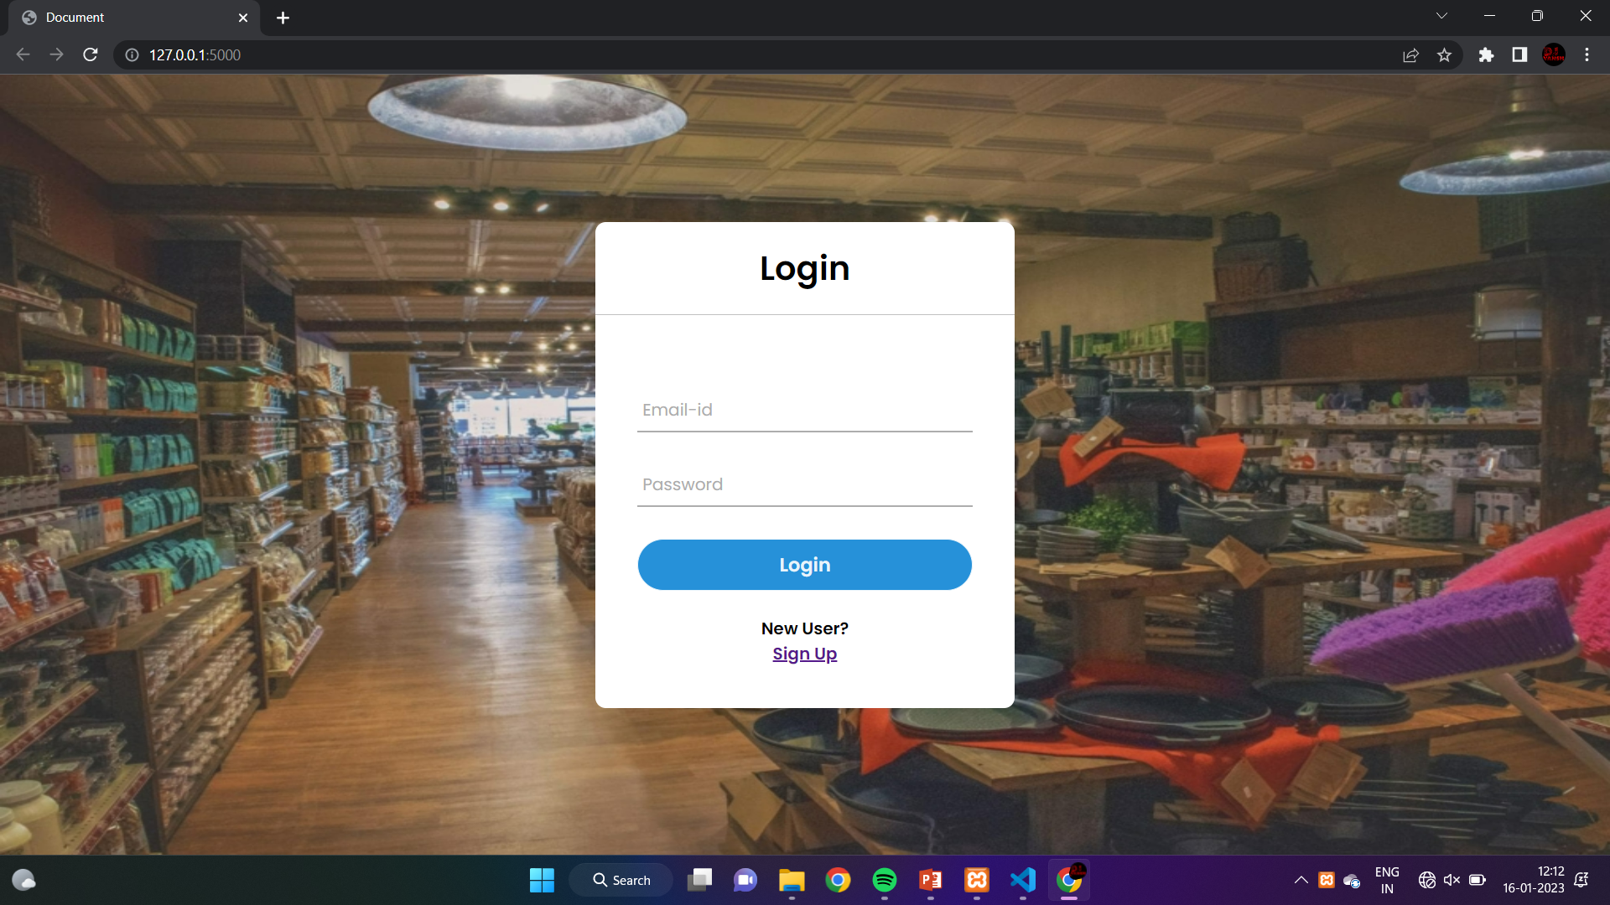

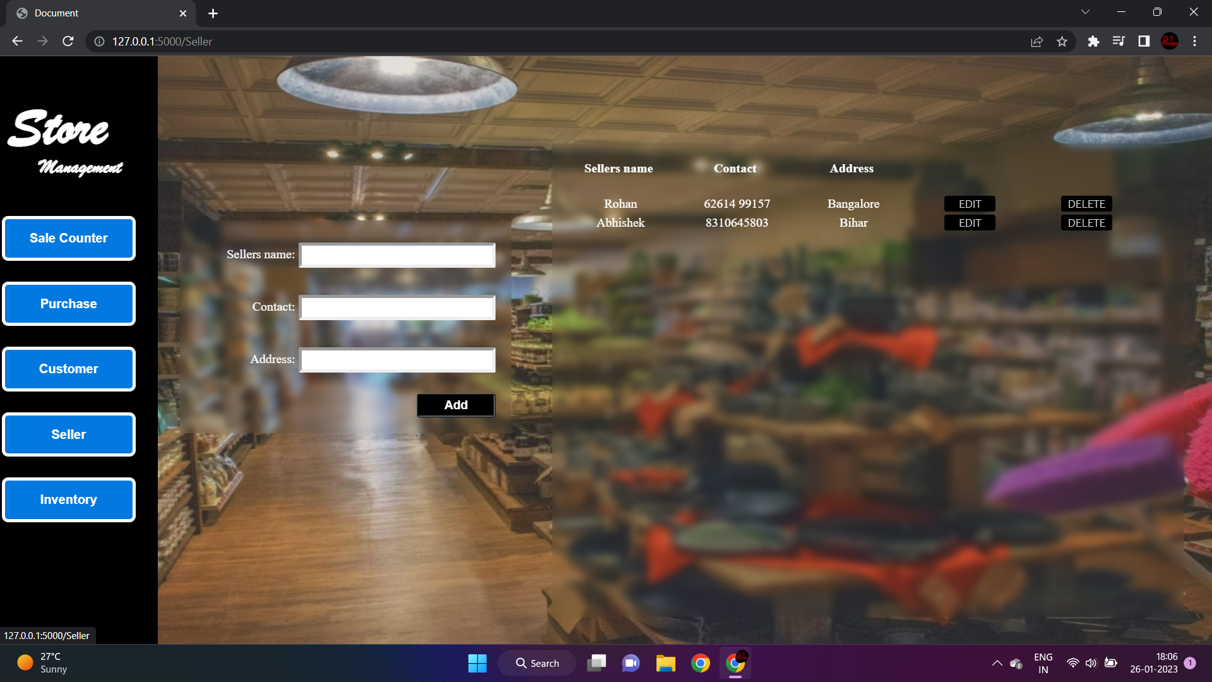**SELLER PAGE**

**CUSTOMER PAGE**

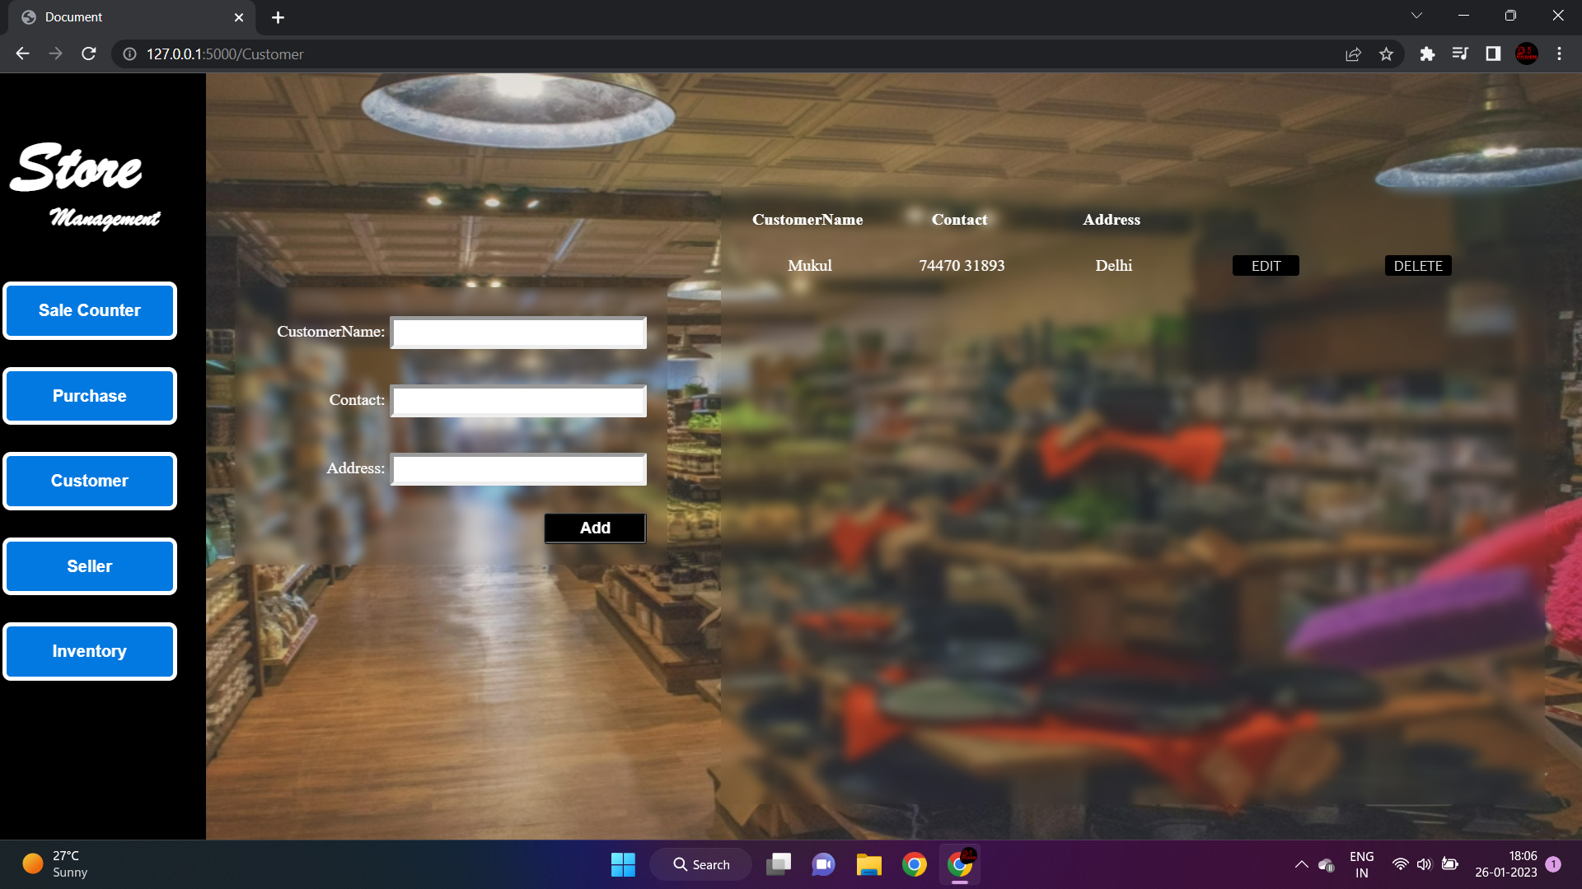

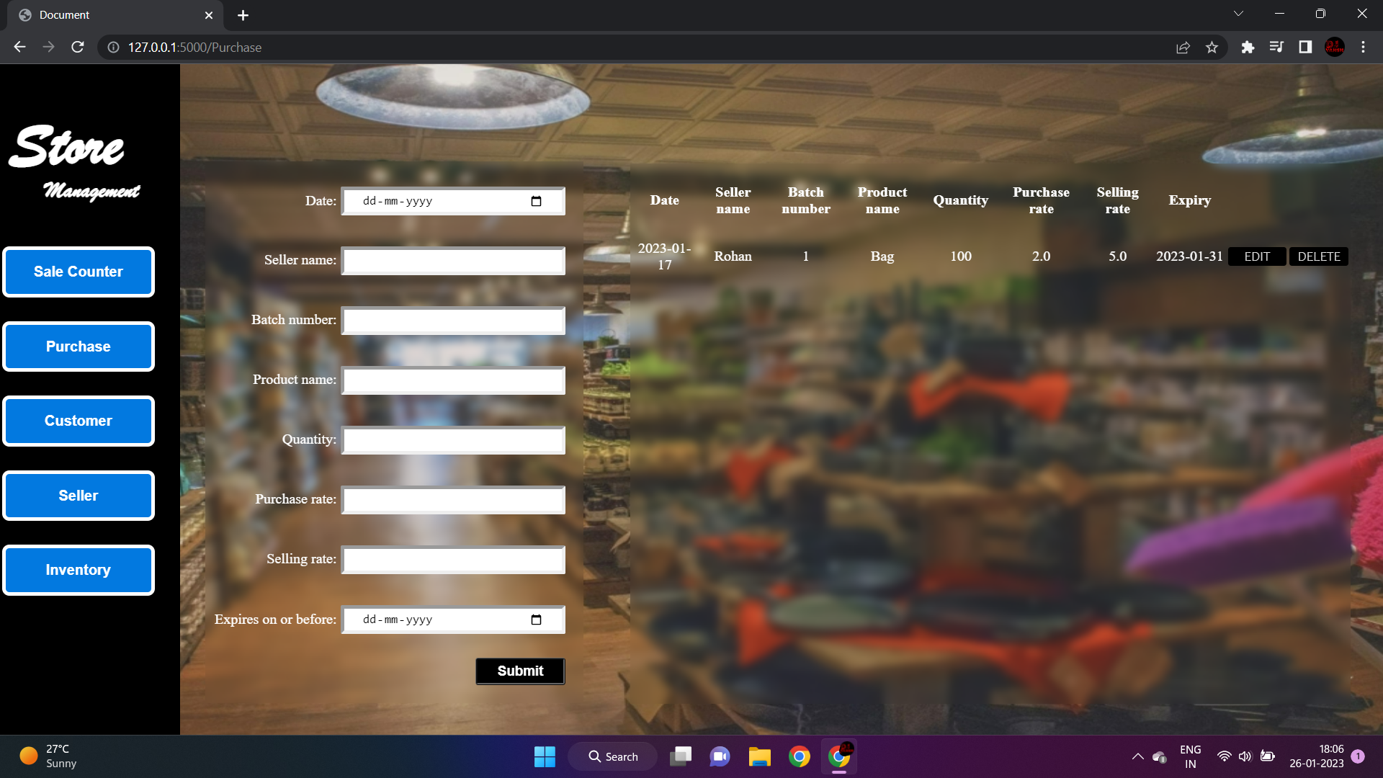**PRODUCT PAGE**

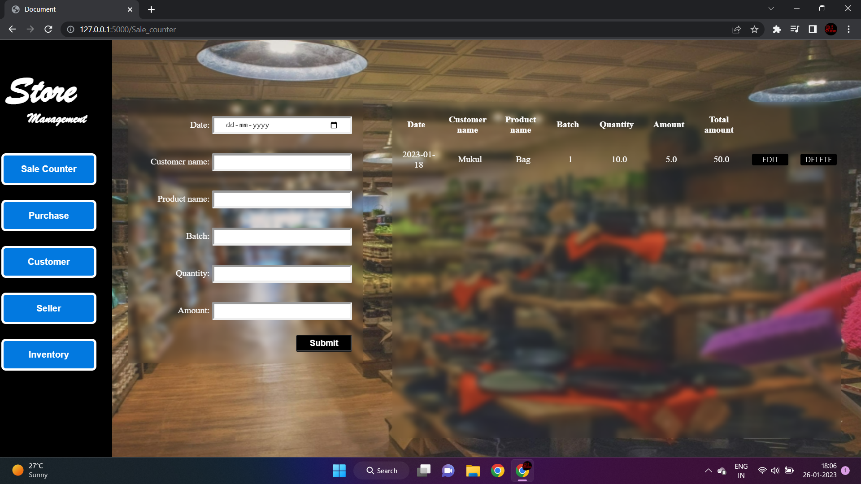**SALE PAGE**

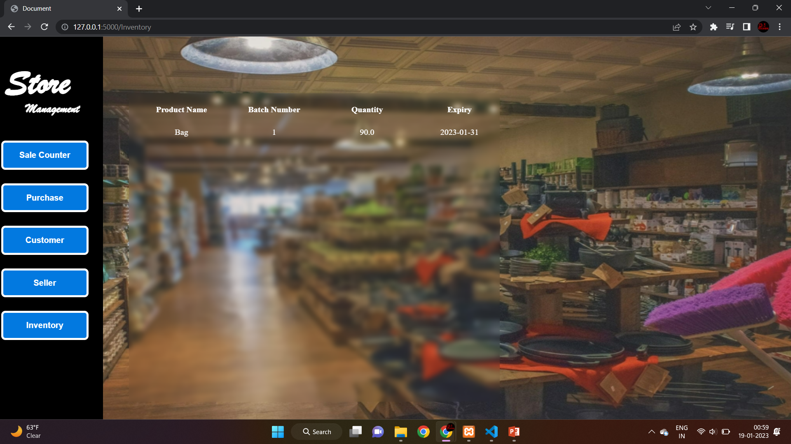**INVENTORY PAGE**